WellnessHub – Personalized Wellness Management Program

System Proposal

CP3540 – Applied ASD Project
2026 07 16
Table of Contents

- Introduction
- Scenarios and use cases
- Architecture
- System entities
- Activities
- Sequences
- States
- Conclusion
Introduction

WellnessHub will be built around a simple, flexible design. Users will be able to easily navigate to desired sets of wellness-related information and tracking tools through the dashboard. Such information will be generated by providers, who will have access to a Markdown-based entry system for creating articles. The system is designed to be implemented in a modular manner, making possible additions such as a dedicated mobile app and a future transition to a fully serverless model without disrupting the user experience.
WellnessHub is centered around aiding users, rather than exploiting them. Users can track their own goals and progress, but the information is not used for any other tracking purposes. Users, and only users, will have access to their personal information, along with any derived values and suggested articles, which will be securely stored and transmitted.
Scenarios and use cases
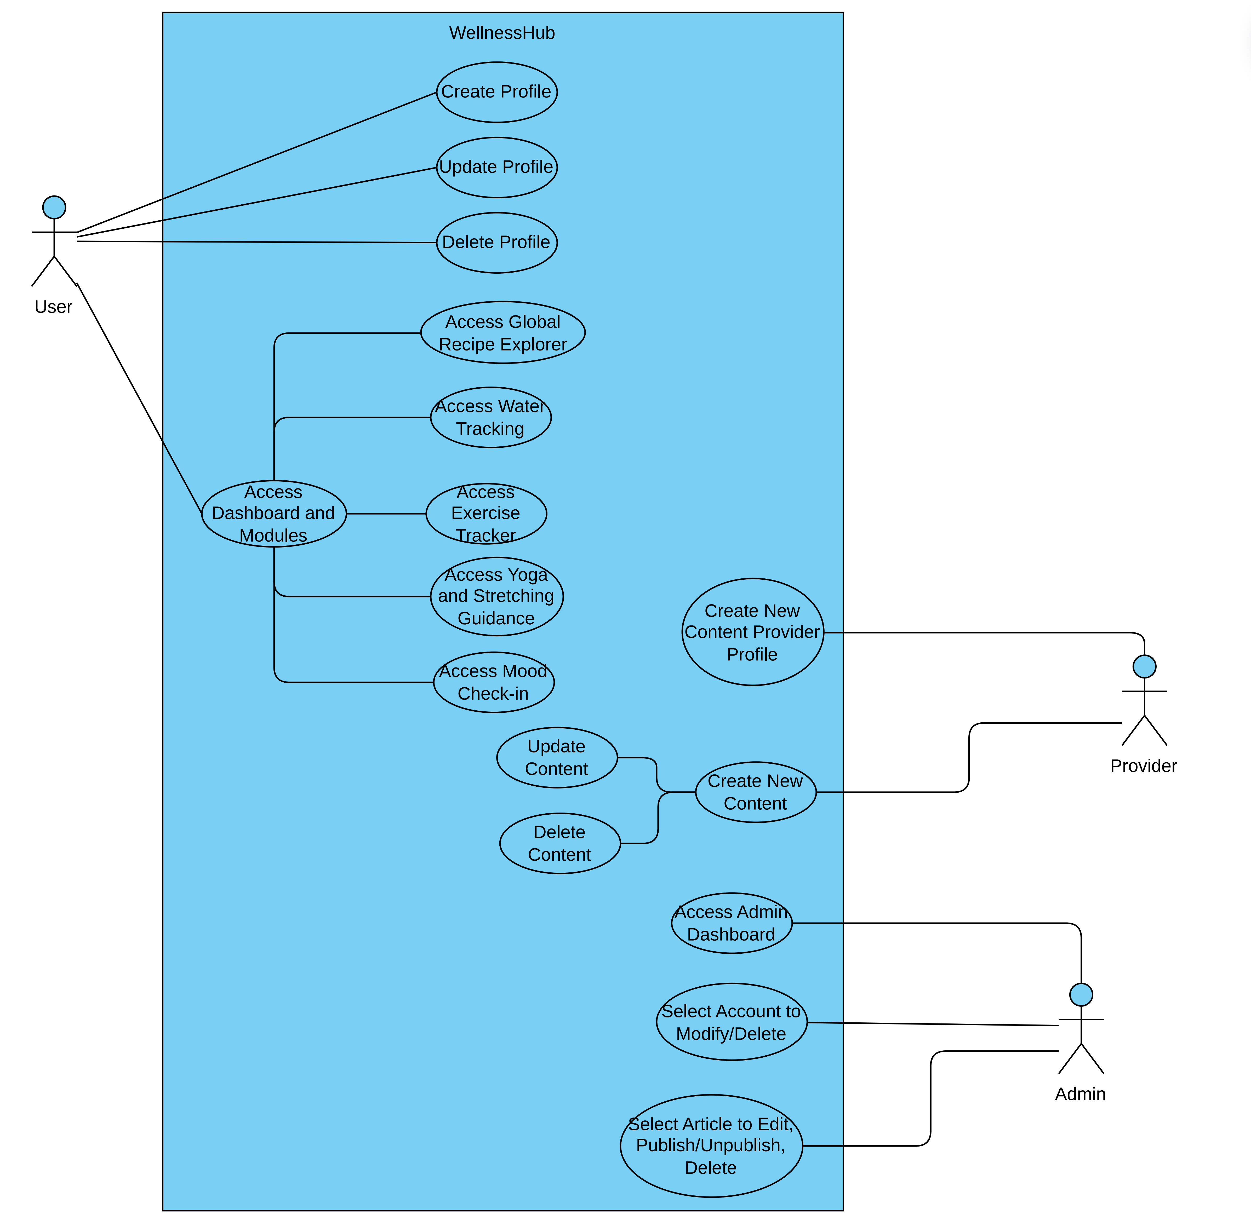
Architecture
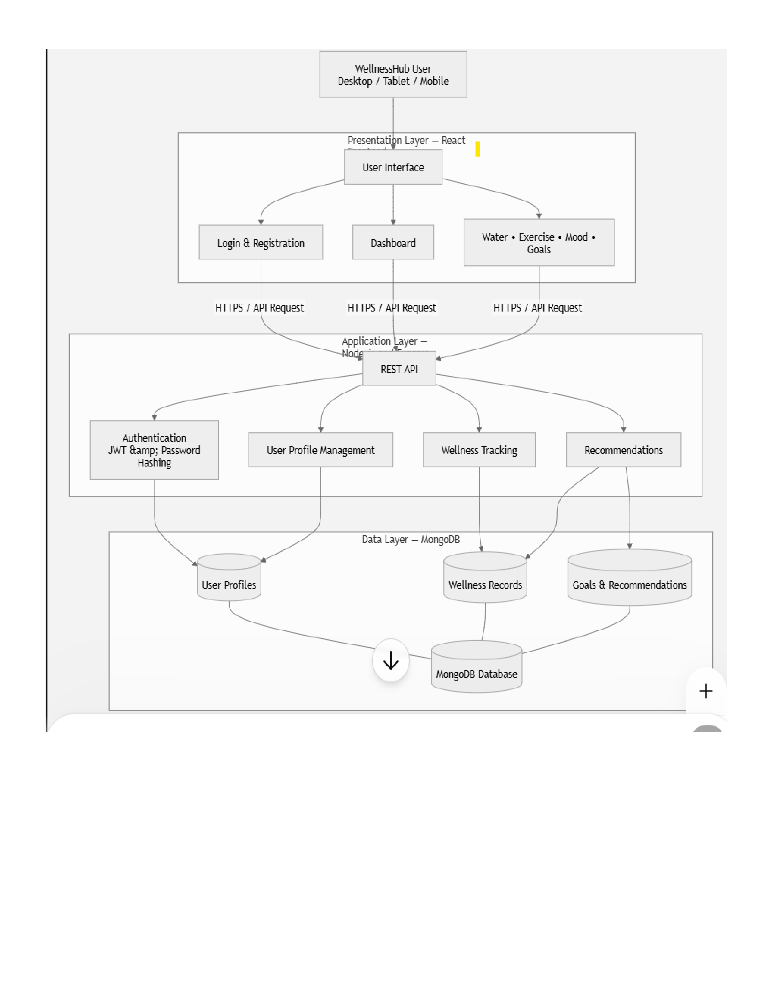
System entities

The primary system entities in WellnessHub are:
- Accounts – users, providers, and administrators
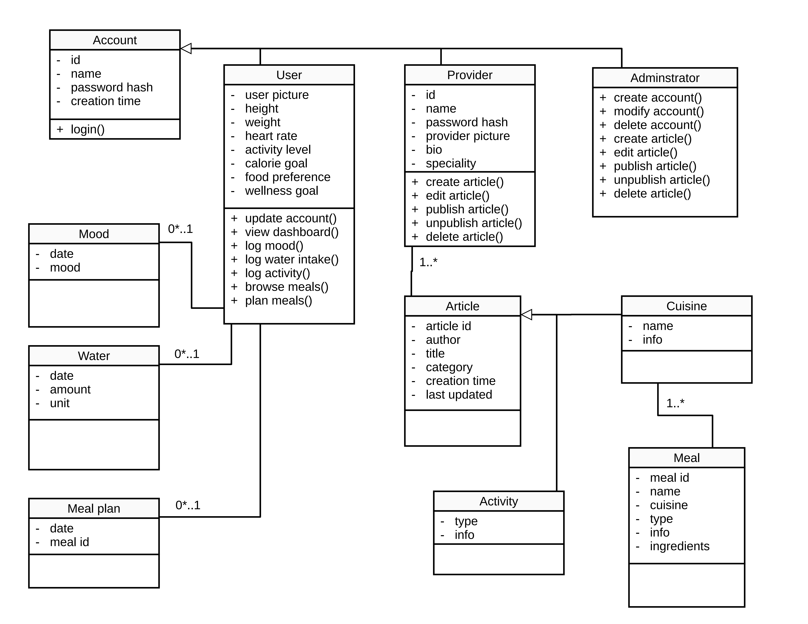
- Articles – information for users, such as walking plans, exercises, meditation, and other wellness-related activities, along with information on meals grouped by cuisine
User accounts have other entities attached for mood, water, and activity tracking, as well as meal planning.
Activities

Sequences

States

Conclusion

